Introduction to Problem Solving and Programming
VITyarthi — Build Your Own Project
PASSWORD GENERATOR & SAVER
A Python console tool that generates strong passwords, rates their strength, and saves them under a label
Field | Details
Student Name | Khandelwal Vinay Chandrakantbhai
Registration No. | 26BCE11663
Branch | CSE Core
College | VIT Bhopal University
GitHub Repository | https://github.com/CoderGoku07/Password-Generator
Date | 30-09-2026

2. Introduction
Coming up with a strong, unique password every time you sign up for something is tedious, so most people end up reusing a handful of weak ones. This project is a small Python console tool that removes the excuse: it generates a genuinely random password, tells you exactly how strong it is, and lets you save it under a simple label so it can be found again later instead of being forgotten or written down somewhere unsafe.
The project keeps things intentionally simple — no external libraries beyond the Python standard library, no database, no GUI — while still being organised into separate files by responsibility, with input validation and automated tests, rather than being one long script.

3. Problem Statement
A lot of people use weak or repeated passwords because coming up with a strong, random one every time is annoying, and then remembering which password goes with which account is another problem on top of that.
This project addresses that with a console program that generates strong random passwords, rates how strong a password actually is using entropy (not just a rough guess), and lets the user save passwords under a label so they can be looked up again later.

Scope
- In scope: generating passwords with a chosen length/character mix; rating password strength; saving, viewing, searching, and deleting saved passwords by label; basic stats on saved passwords.
- Out of scope for this version: encrypting the saved passwords (see the note in Section 8 and the README — this is a known, deliberate limitation, not an oversight); a GUI; multiple user accounts.

Target Users
- Anyone who wants a quick, genuinely random password without having to think one up themselves.
- Students who want a simple place to keep track of test logins/project accounts without setting up or paying for a full password manager.

4. Functional Requirements
The project has three core functional modules, each with a clear input and output, satisfying the "at least three major functional modules" requirement.
# | Module | Capability | Input → Output
1 | Password Generation | Generate one or more random passwords with a chosen length/character mix | Length + character-type choices in → password string(s) out
2 | Strength Checking | Calculate entropy and give a Weak/Medium/Strong/Very Strong rating | Password string in → entropy + rating out
3 | Saved Password Management | Save, view, search, delete passwords by label; see stats across all saved entries | Label (+ password) in → saved entry / list / stats out
Workflow: pick a menu option → enter the requested details → the relevant module processes them → a confirmation or error message is printed. Every option follows this same loop.

5. Non-functional Requirements
Requirement | How it is addressed
Performance | The saved-password file is small (a handful of entries for one user), so loading it fully into memory on each operation is fast enough — no indexing or database needed at this scale.
Security | Passwords are generated with Python's secrets module (a proper randomness source, not the predictable random module). Saved passwords, however, are currently stored as plain text — this is a known limitation, explained in Section 8 and listed as the top item under Future Enhancements.
Usability | A numbered text menu with short prompts and sensible defaults (press Enter to accept) so the tool needs no separate instructions to use.
Reliability | Every menu action is wrapped in a try/except in main.py, so an invalid input or a missing label produces a clear message instead of the program crashing.
Maintainability | Each piece of functionality lives in its own file (generator.py, strength.py, vault.py, storage.py, validators.py) with a short comment explaining what it does and why.

6. System Architecture
main.py is the only file that talks to the user. It calls into generator.py, strength.py and vault.py to do the actual work. vault.py leans on strength.py (to rate a password before saving it) and on storage.py, which is the only file that reads or writes the data file on disk.

Figure 1: System Architecture Diagram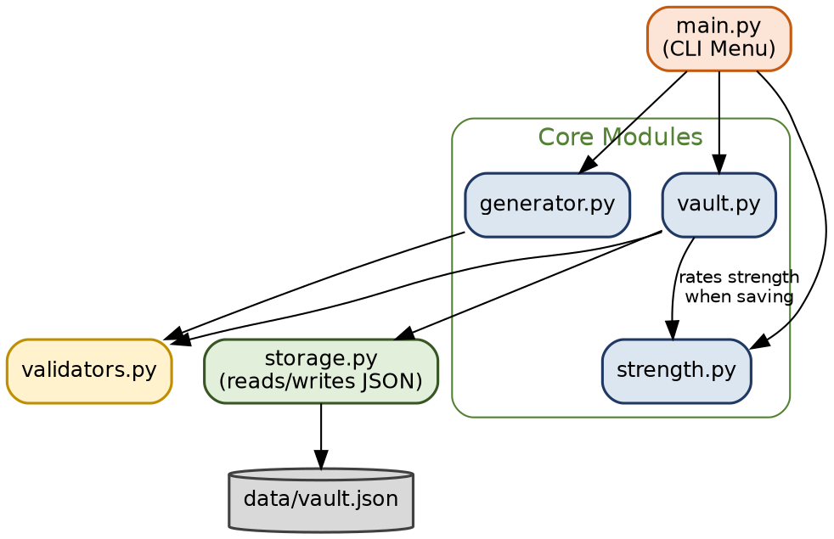

7. Design Diagrams

7.1 Process Flow / Workflow Diagram — Save a Password

Figure 2: Workflow Diagram for "Save a Password"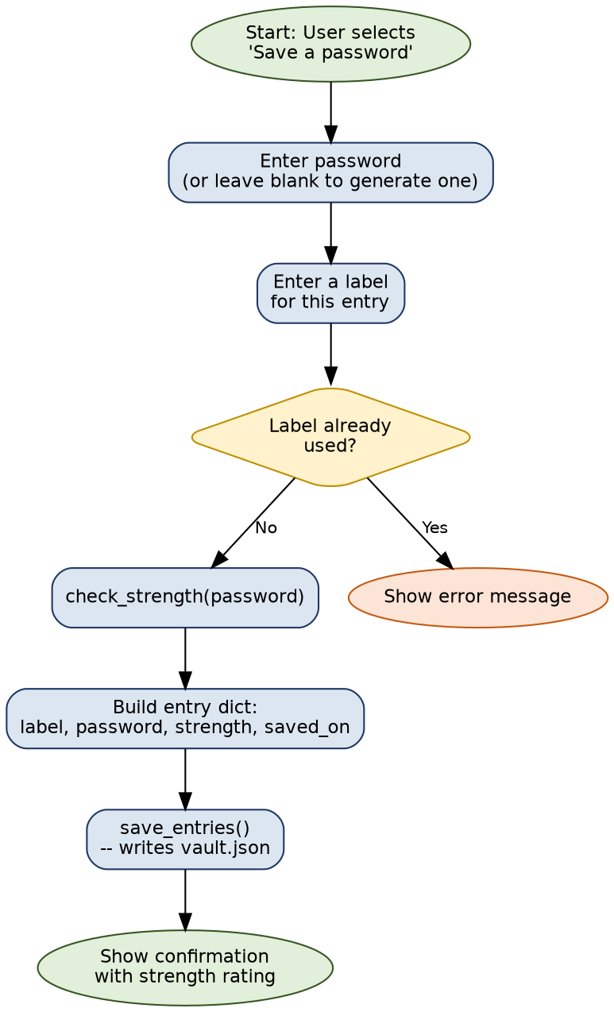

7.2 Use Case Diagram
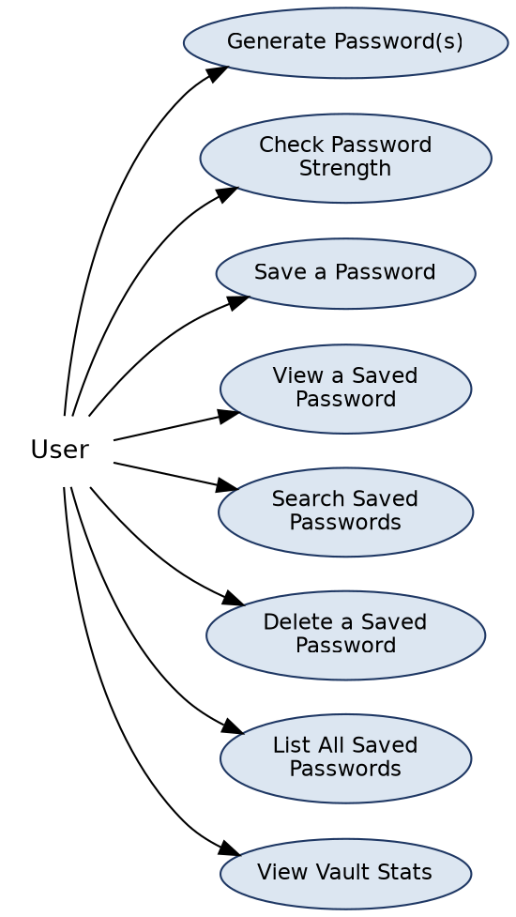

Figure 3: Use Case Diagram

7.3 Component Diagram
This project is written as plain functions grouped into modules rather than classes, so a component diagram (showing which module calls which) fits better here than a formal UML class diagram.
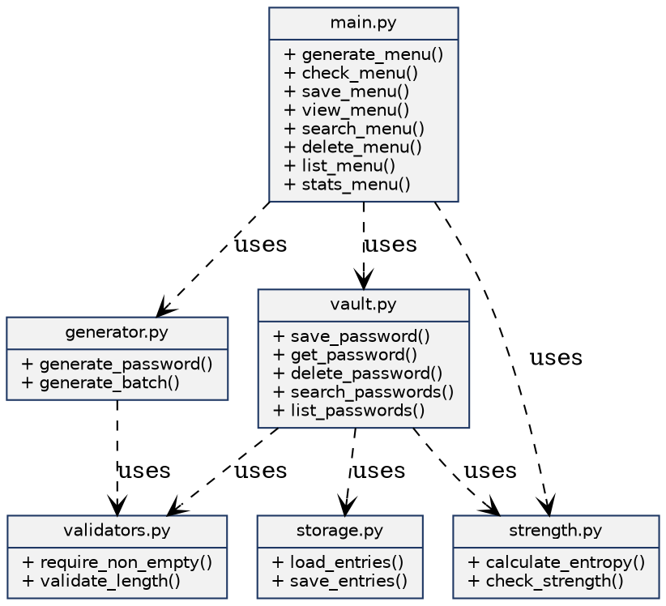
Figure 4: Component Diagram

7.4 Sequence Diagram — Save a Password
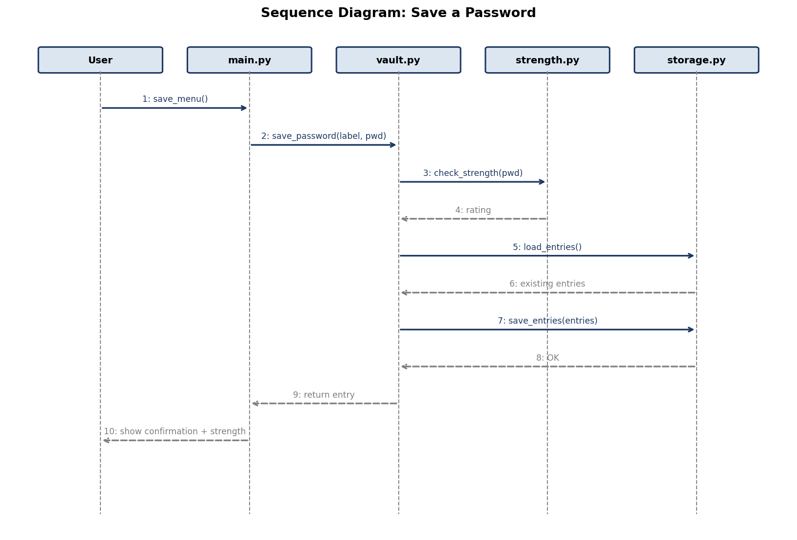
Figure 5: Sequence Diagram for "Save a Password"

7.5 Storage / Schema Design
There is a single record type — a saved password entry — stored as a list of these in data/vault.json. No relational structure is needed since there is only one entity with no links to other data.
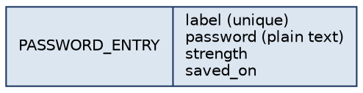
Figure 6: Saved Password Entry Schema

8. Design Decisions & Rationale
- secrets over random for generation: random is predictable if you see enough of its output, which makes it unsuitable for anything security-related, even in a simple project like this.
- Entropy for strength rating instead of just checking length: a long password made of only lowercase letters is still weaker than a shorter one that mixes character types, and entropy captures that properly.
- Plain functions and dicts instead of classes: the project is small enough that a full object-oriented design (custom classes, inheritance) would add complexity without a real benefit — a dict per saved entry and a handful of functions per module is easier to read and matches the size of the problem.
- Plain-text password storage — a deliberate, known limitation: I chose to get the full save/view/search/delete flow working correctly first rather than build encryption I hadn't fully understood. Storing passwords as plain text means this tool should not be used for real, important passwords as-is; encrypting the vault with a master password is the natural next step, listed under Future Enhancements.
- One file per responsibility (generator, strength, vault, storage, validators): keeps each file short and focused, and makes it obvious where to look when something needs to change.

9. Implementation Details
The project has 6 source modules (main.py, generator.py, strength.py, vault.py, validators.py, storage.py) plus a tests/ folder with 2 test files.

9.1 storage.py
storage.py
# storage.py
# saves and loads the passwords from a json file

import json
import os

VAULT_FILE = os.path.join(os.path.dirname(os.path.abspath(__file__)), "data", "vault.json")

def load_entries():
if not os.path.exists(VAULT_FILE):
return []
with open(VAULT_FILE, "r") as f:
return json.load(f)

def save_entries(entries):
with open(VAULT_FILE, "w") as f:
json.dump(entries, f, indent=2)

9.2 validators.py
validators.py
# validators.py
# checks the user input, used by generator.py and vault.py

def check_not_empty(value, name):
value = value.strip()
if value == "":
raise ValueError(name + " cannot be empty")
return value

def check_length(value):
try:
length = int(value)
except ValueError:
raise ValueError("Length must be a number")
if length < 4 or length > 64:
raise ValueError("Length must be between 4 and 64")
return length

9.3 main.py
main.py
import random
import string
print("=" * 45)
print(" PASSWORD GENERATOR")
print("=" * 45)
print()
print("Create a strong password easily.")
print("Answer Yes or No for the options below.")
print()
# Ask the user for password length
length = int(input("Enter password length: "))
print()
# Ask which characters the user wants
capital = input("Include capital letters (A-Z)? Yes/No: ")
small = input("Include small letters (a-z)? Yes/No: ")
numbers = input("Include numbers (0-9)? Yes/No: ")
symbols = input("Include special characters (!@#$)? Yes/No: ")
# Convert answers to lowercase
capital = capital.lower()
small = small.lower()
numbers = numbers.lower()
symbols = symbols.lower()
# Create an empty character list
characters = ""
# Add characters according to the user's choice
if capital == "yes":
characters = characters + string.ascii_uppercase
if small == "yes":
characters = characters + string.ascii_lowercase
if numbers == "yes":
characters = characters + string.digits
if symbols == "yes":
characters = characters + string.punctuation
print()
# Check if the user selected at least one option
if characters == "":
print("Error: You must select at least one option.")
else:
# Check password length
if length <= 0:
print("Error: Password length must be greater than 0.")
else:
password = ""
# Generate the password
for i in range(length):
character = random.choice(characters)
password = password + character
print("=" * 45)
print(" PASSWORD GENERATED")
print("=" * 45)
print()
print("Your password is:")
print(password)
print()
print("Password length:", length)
print("=" * 45)
print()
print("Thank you for using Password Generator!"

10. Screenshots / Results
Below is an actual captured console session: generating passwords, saving one, listing saved entries, searching, viewing a saved password, and checking vault stats.

=============================================
PASSWORD GENERATOR
=============================================
Create a strong password easily.
Answer Yes or No for the options below.
Enter password length: 12
Include capital letters (A-Z)? Yes/No: Yes
Include small letters (a-z)? Yes/No: Yes
Include numbers (0-9)? Yes/No: Yes
Include special characters (!@#$)? Yes/No: Yes
=============================================
PASSWORD GENERATED
=============================================
Your password is:
Gk7@pQ2#xLm9
Password length: 12
=============================================
Thank you for using Password Generator

11. Challenges Faced
- Picking a strength formula that actually means something, instead of just "length > 8 = strong": settled on entropy (length × log2 of the character pool used) since it accounts for character variety, not just length.
- Deciding what to do about storing the actual passwords: the honest answer is I didn't build encryption for this version, so I made that limitation explicit in the README, statement.md, and this report rather than pretending the vault is more secure than it is.
- Handling a duplicate label without crashing: save_password() checks existing entries first and raises a clear ValueError instead of silently overwriting an existing entry.
- Keeping main.py from turning into one giant function: split it into one small function per menu option (generate_menu, save_menu, etc.) so each one is easy to follow on its own.

12. Learnings & Key Takeaways
- Why secrets exists as a separate module from random, and when that distinction actually matters (anything security-related).
- What entropy means for a password and why it's a better strength measure than just eyeballing length.
- That it's better to clearly document a limitation (like plain-text storage here) than to either skip it silently or half-build a security feature I didn't fully understand.
- Splitting a program into small, single-purpose files makes it much easier to test each part on its own.

13. Future Enhancements
- Encrypt the vault: derive a key from a master password and encrypt each saved password before writing it to the file, so it isn't stored as plain text.
- Check generated/saved passwords against a list of commonly leaked passwords.
- Add an option to copy a revealed password straight to the clipboard instead of printing it.
- A basic GUI (Tkinter) instead of the console menu.
- An auto-expiring "remember to change this" flag for old or weak saved passwords.

14. References
- Python Software Foundation — Python 3 Standard Library documentation (secrets, json, math, unittest modules). https://docs.python.org/3/
- Python secrets module docs — why it's recommended over random for security purposes.
- Graphviz documentation, used to generate the architecture, use case, component and schema diagrams. https://graphviz.org/documentation/
- Course material and project brief: "VITyarthi — Build Your Own Project", Introduction to Problem Solving and Programming, VIT Bhopal.

